**Hosting a static website in Ec2**

ec2-54-156-90-32.compute-1.amazonaws.com

First Launch an Ec2 instance from AWS Console, we have free option available right now so select that.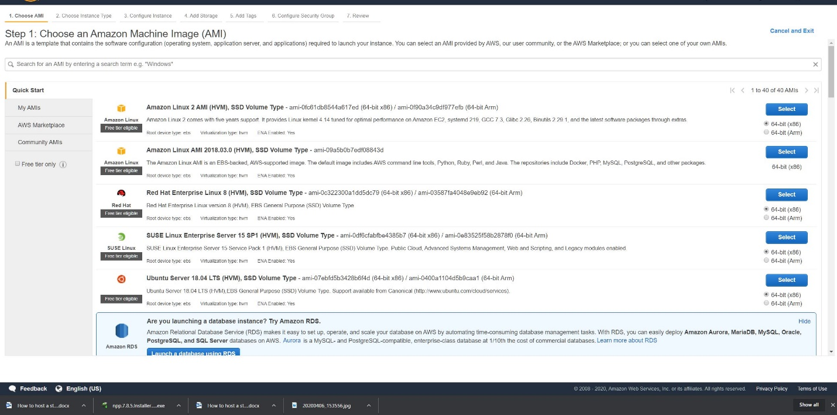

Select the Tier

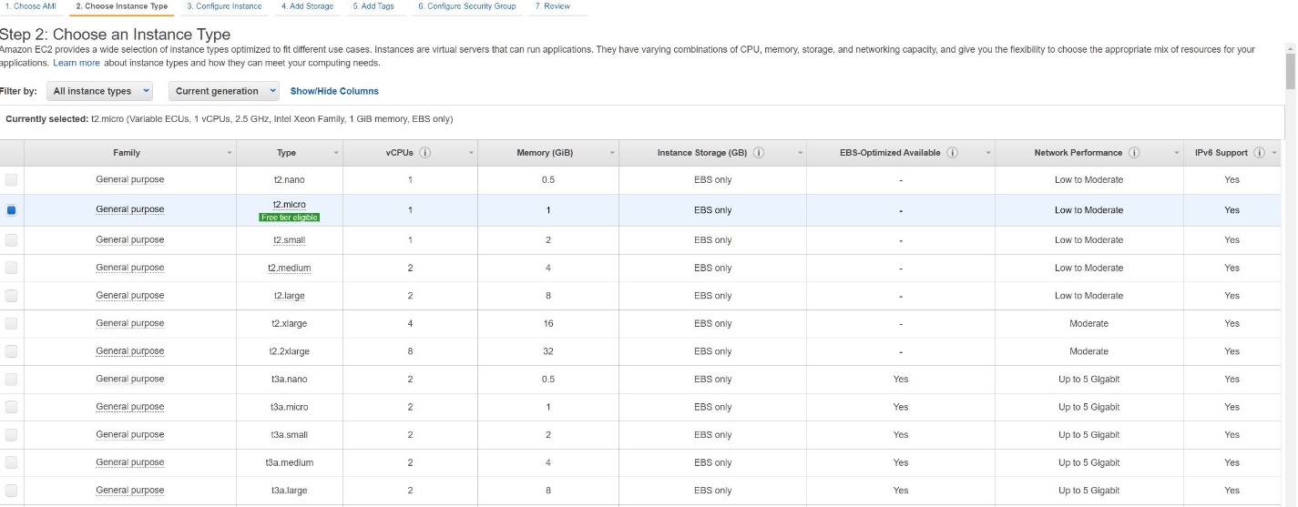

Add storage

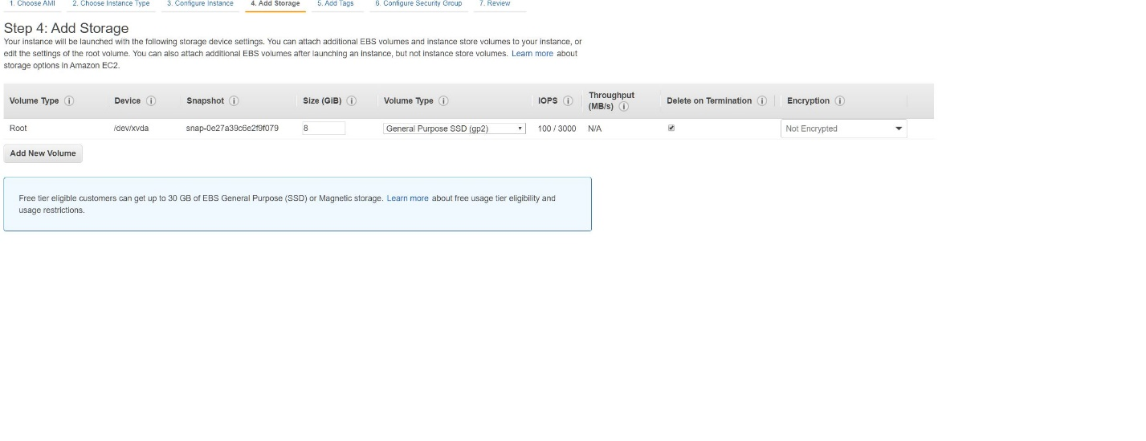

Add a Tag or Tags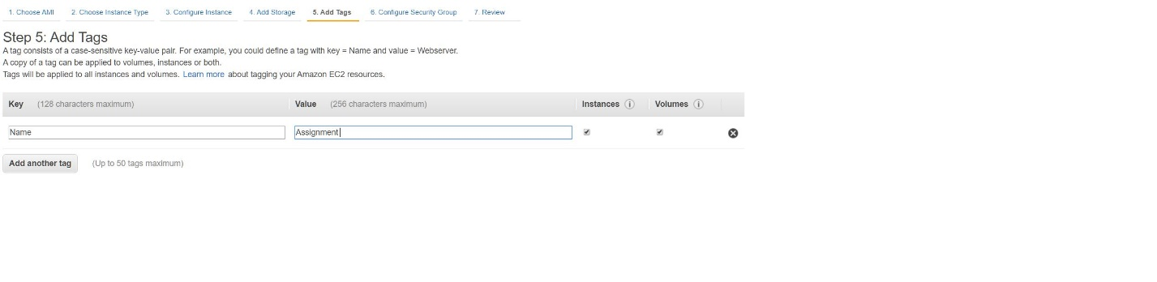

Customize Security Group according to requirements

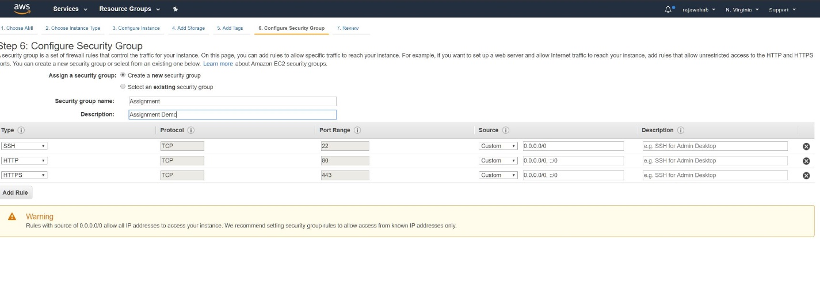

Create New Keypair and Launch the Instance

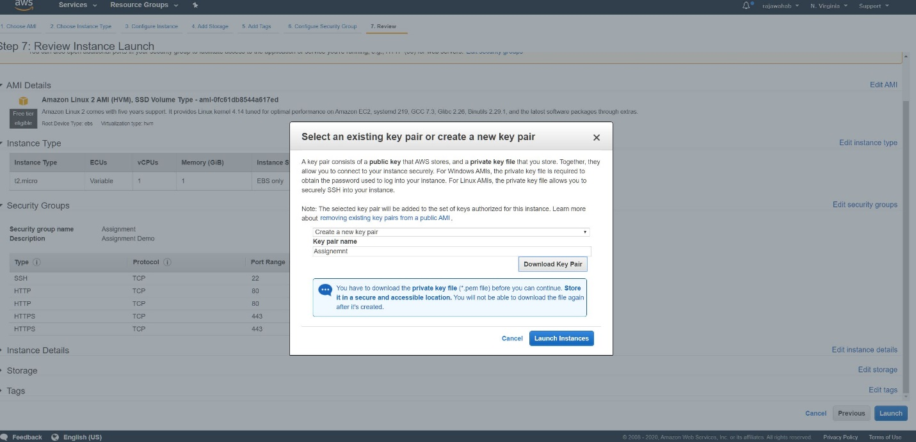

The Instance has been started

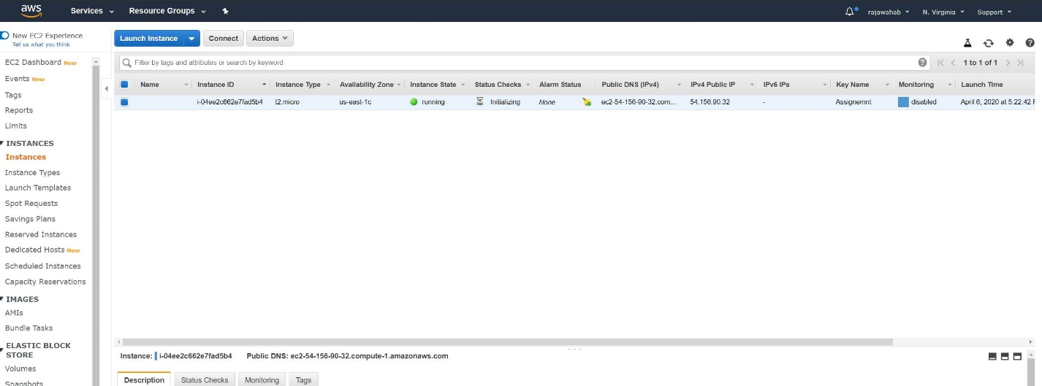

Open Putty Key Generator to Generate a Key in PPk format

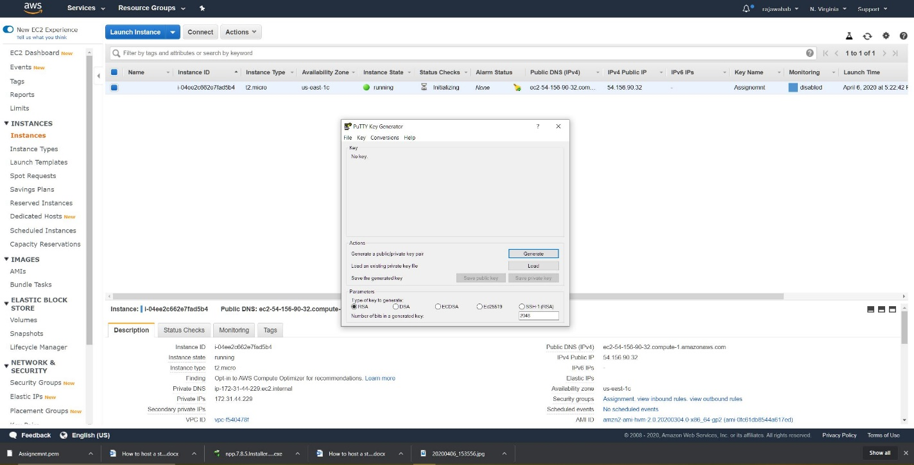

Open Putty to Connect to Linux instance

Copy the IP 54.156.90.32 and insert to Putty

Use YUM command to update the Linux instance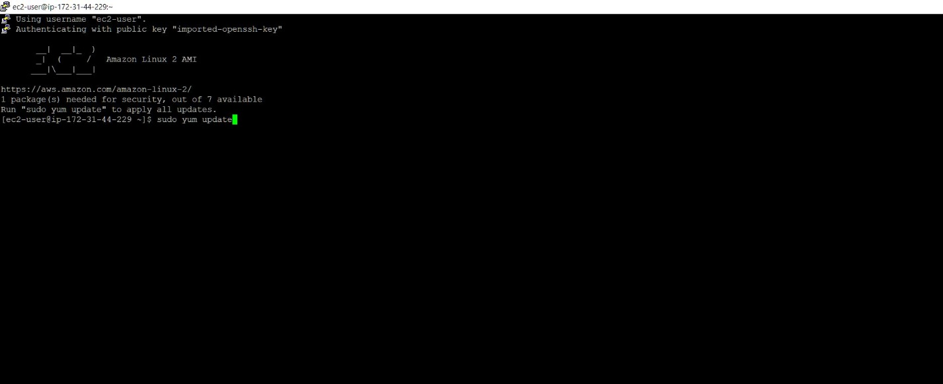

Connect to Root user

Check the service status of httpd

If not installed install it with command yum install httpd

Httpd is installed now start it with command service httpd start

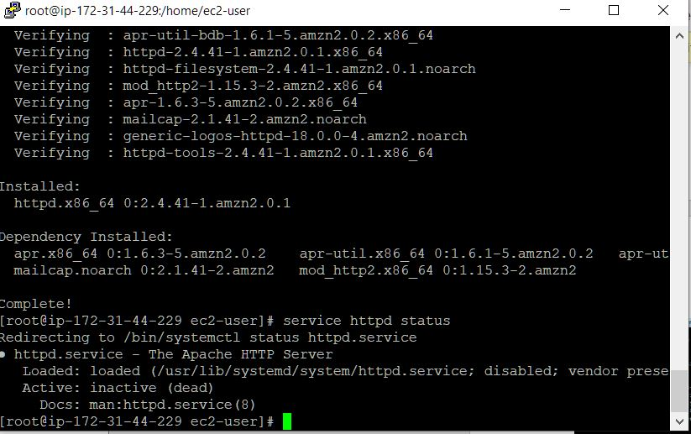Verify it with IP of your Linux Instance

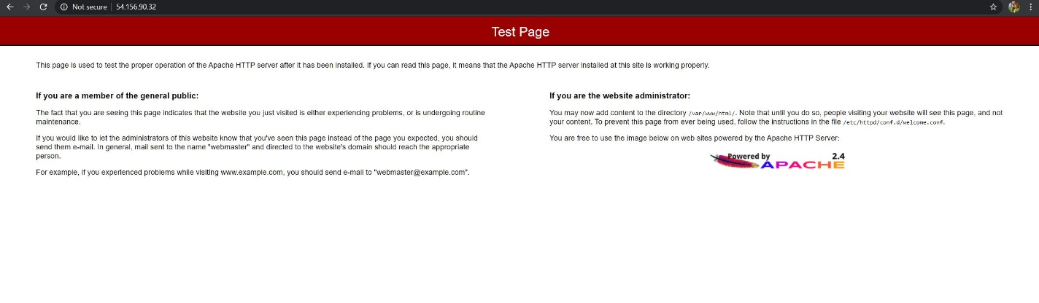

To customize the Apache httpd service page change the directory to /var/www/html. Command: cd /var/www/html

To check who owns the folder check command ls -l /var/www/

As we can see root user owns the folder

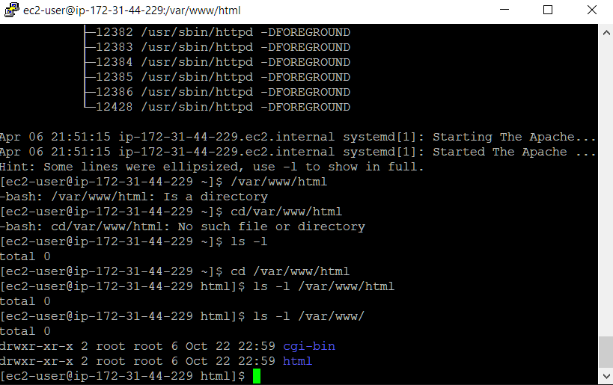

Change your directory to root use command vi index.html and create a simple html web page.

